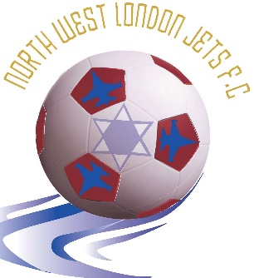
Chairman: Yoni Weichselbaum
Secretary: Aaron Weichselbaum

Dear Parents,

Thank you for expressing an interest in your daughter/son playing football with North West London Jets (NWLJ) in the 2020-21 season. NWLJ is an inclusive football club for Jewish children and young people. We offer after-school training by FA certified coaches. Our teams participate in the Maccabi GB Junior Football League (MGBJFL).

This pack contains all the information you need to register your child for participation in weekly after-school training and matches on Sundays.

In order to register your child to participate in the MGBJFL you need to provide the following:

- A completed Maccabi registration form.
- A copy of the player’s birth certificate or passport.
- One recent passport sized photo.
- A completed consent form giving NWLJ permission to take and use photos of your child on their website (optional)
- A completed NWLJ registration form.
- NWLJ kit order form (for new players or players who require a new kit).
- Respect Code of Conduct Agreement.

The cost for registering your child to play and train for the year is £420 and covers three terms of training at Mill Hill Power League, playing in matches in the Maccabi GB Junior Football League, football equipment, insurance, the annual awards and payments to coaches and other expenses. This can be paid in instalments (see registration form for details).
The North West London Jets FC football kit costs an additional £35.
The cost for training only is £70 per term or £210 for the year.

In accordance with the Data Protection Regulatory Policy (GDPR), North West London Jets have published policies and details available to view on the website here & here and is fully compliant with the stipulated requirements.
Please return the aforementioned forms to the address below. Cheques should be made payable to North West London Jets. Alternatively, you can pay by bank transfer: Branch sort code: 51-50-11, Account number: 66597056. If you have any questions, please contact Aaron on 07956 121740 or email aaronnwlj@hotmail.co.uk.

Contents
North West London Jets 3
About us 3
Training: 3
Times for training are as follows: 3
Sunday Matches: 4
Match format for each age group is as follows: 4
Team Management: 5
Power Play 5
Sin Bins 5
FORM 1: North West London Jets FC Registration Form 7
Football Kit Requirements 9
FORM 3: North West London Jets Kit 10
FA Respect Code of Conduct for Spectators: 12
FA Respect Code of Conduct for players 13
FORM 4: Signing up to the FA Respect Codes of Conduct 13
FORM 5: North West London Jets (NWLJ) Consent Form 15

North West London Jets

About us

North West London Jets is an inclusive Jewish football club for children and young people. We pride ourselves on providing a safe, enjoyable yet disciplined environment for our players to develop both as footballers and people. We believe all players should be treated equally and given the opportunity to be part of a great team.

We provide a great introduction to football, which ensures that all players:

- Take an active part in the game
- Learn to play as a team
- Understand the rules
- Develop football skills
- Are able to take part whatever their ability
- Develop fitness
- Enjoy themselves

We set a standard for behaviour on and off the pitch. Fair play and respect for other people is very important to our club and we strive to make sure that all children and parents alike show respect for other players, coaches, supporters and match officials.

Training:

- The coaching is carried out by FA qualified coaches.
- We develop coaching sessions to enable each child to fulfil their potential.
- Priority for playing on Sundays is given to children that train with NWLJ.
- Training takes place on Wednesday evenings at Mill Hill Power League, Pursley Road, Mill Hill.

Times for training are as follows:
Age Group | Time of Training
Under 7’s | 4:30pm – 5:30pm
Under 8’s | 4:30pm – 5:30pm
Under 9’s | 4:30pm – 5:30pm
Under 10’s | 5:30pm – 6:30pm
- The cost of training on its own per term is £70.

Sunday Matches:

Age Group | Venue for Matches
Under 7’s | Woodhouse College
Under 8’s | Woodhouse College
Under 9’s | The Hive
Under 10’s | The Hive
- NWLJ participates in the Maccabi GB Junior Football League for ages 6-10. Matches take place on Sunday afternoons at the following locations:
- Kick off times in the Maccabi GB Junior Football League vary between 2.30pm, 3.30pm or 4.30pm.
- These times are set by the MGBJFL Fixtures Secretary and you will be informed of the kick off times during the week preceding the match. Alternatively, check the club website: www.nwlj.co.uk

Match format for each age group is as follows:

Age Group | Match Format | Length of Match
Under 7’s | 5 v 5 | 40 minutes (20 minutes each half)
Under 8’s | 5 v 5 | 40 minutes (20 minutes each half)
Under 9’s | 7 v 7 | 50 minutes (25 minutes each half)
Under 10’s | 7 v 7 | 50 minutes (25 minutes each half)

- Players must arrive at the match venue 20 minutes before the stated kick-off time.
- Each week, you will be asked to confirm your child’s attendance. Those that confirm by the deadline will get priority for playing on Sunday.
- Children should bring a bottle of water or another still drink to games and training.
- When attending Maccabi football matches parents must stand behind the green gates at all times. Only the manager is allowed pitch-side.
- Your support during matches helps motivate the players and team. Come along and support the players.

Team Management:

Each team is managed by volunteers. The role of the manager is to:

- Decide team selection, composition, positioning of players and substitutions.
- For Cup Competitions managers may decide to select players who they consider are best suited for the occasion.
- Stand on the touch-line giving encouragement and guidance to players.
- Remain with players until parents/nominated guardians have collected them.
- Provide feedback to the coaches that train the players during the week.

Managers play an important but challenging role. If you are interested in becoming a team manager or helping out on the touchline, please let us know.

Note: for under 7s games, parents may be asked to referee. A whistle and stopwatch is provided.

Power Play

The Football Association introduced the Power Play rule in the 2018 - 2019 football season for mini soccer and youth grassroots football teams. The purpose of the Power Play rule is to ensure that mini soccer and youth matches remain competitive and fun in situations where there is an imbalance in ability.

Power Play works as follows:
- If a team is losing by a four goal difference they can put an additional player on – so 5v5 becomes 6v5.
- If the score returns to less than a four goal difference the team takes off a player. It does not have to be the last player to come on.
- If a team goes on to be losing by a six goal difference a further additional player can be added - so 6v5 becomes 7v5.
- The main aim of the Power Play option is that all players are being challenged and enjoying the game.
- Power Play is available through all mini soccer football formats 5v5 and 7v7.
(NWLJ Website - Power Play)

Sin Bins

IFAB, the International Football Association Board, on 3rd March 2017 approved the use of temporary dismissals in grassroots football, referred to as Sin Bins.
A player can be sent to the sin bin by the referee showing a Yellow card for dissent. In such a situation a player will have to remain in the sin bin for an 8 to 10 min period, depending on the duration of the match. When a player is in a sin bin the team will be reduced in number, until the referee confirms that the player who has been sent to the sin bin is allowed to return to the field of play.
A player who is serving their time in the sin bin cannot be substituted. The player must serve the duration of their time in the sin bin, before the manager can substitute them.
A player who has been sent to the sin bin twice in the same match for dissent will not be allowed to return to the field of play for that match after serving out their second sin bin period. After the second stint in the sin bin has been completed the manager will be allowed to substitute the offender, in order to restore the team to 11, 9, 7 or 5 players (depending on the match format).
There is no official designated area for a sin bin. A sin bin can be the touchline, where the Manager and Assistant Manager are positioned. A player in the sin bin is allowed to warm-up but cannot actively participate in the match, until they have completed their time in the sin bin.
A player who has received a Yellow Card for dissent can receive up to 3 Yellow Cards in a game. Two Yellow Cards, when one is issued for dissent (sin bin), does not equate to a sending off or suspension. However, if a player receives a Yellow Card for dissent, they will be sent to the sin bin. The player may then return to the field of play, where they could commit a foul which results in another Yellow Card being awarded to the same offender. Therefore, the one player will have received two Yellow Cards, but can continue to play. Should the same offender receive a third Yellow Card for a cautionable offence, such as a bad tackle, then that player will be sent off and suspended from the next match. However, should the third Yellow Card be awarded for a second instance of dissent, the player will be sent to the sin bin and not allowed to return for the remaining duration of that game, but will not be suspended from participating in the next match.
If a player is serving out their first sin bin offence with 5 min remaining of the match, the sin bin will be considered served at full time. The sin bin does not carry over to the following match in order to complete the usually required 8 or 10 min period. However, if the player has been sent to the sin bin shortly before half time, resulting in the full duration of the sin bin not being served prior to the half time whistle, then the player will continue to remain in the sin bin until the referee allows them to re-enter the field of play in the second half. This means, the team will start the second half a player down, until the sin bin period is served.

(NWLJ Website - Sin Bins for Dissent)

FORM 1: North West London Jets FC Registration Form

North West London Jets – Registration Form

Name of Player:

Player’s Date of Birth (DOB):

Age Group registering for: Please tick the appropriate box.

Under 7 | Under 8 | Under 9 | Under 10

School Attended:

School Year starting September 2020: Please tick the appropriate box.

Year 2 | Year 3 | Year 4 | Year 5

Home Address:

Medical / Additional Educational Needs Information: Please provide information about any medical conditions / related medication and / or additional educational needs that could affect the player’s behaviour or performance.

Parent/ Carer Contact Details:

Name of Parent/ Carer:

Mobile Number 1: Name of Contact

Mobile Number 2: Name of Contact

Home Phone Number:

Parents/ Carer Email Addresses:

Name of Email Address owner:

Is your son/daughter Playing and Training? Training Only? Playing Only?
Please tick the appropriate box.
Playing & Training | Training Only | Playing Only

NB players are expected to attend training and dispensation will only be granted in circumstances where training sessions clash with school commitments.

Payment Enclosed for: Please tick the appropriate box.
£140 First Instalment (Playing & Training)
£280 First & Second Instalment (Playing & Training)
£420 for Whole Year Playing & Training (Instalment 1,2 and 3)
£70 for Term 1 (Training Only)
£140 for Term 1 & Term 2 (Training Only)
£210 for Whole Year Training Only (Instalment 1,2 and 3)
£70 First Instalment (Playing Only)
£140 First & Second Instalment (Playing Only)
£210 for Whole Year Playing Only (Instalment 1, 2 and 3)
Additional £35 for Kit
£46.70 for 9 Monthly Instalments paid by standing order (Playing & Training)

Payment Method: Please tick the appropriate box.
Bank Transfer | Cheque

Instalment Payment Dates:

Activity | Instalment | Instalment Due Date
All | One | When the season starts
 | Two | 29th November 2020
 | Three | 28th February 2021
 | Monthly | 28th of each month  (September 2020 to May 2021

Please make cheques payable to North West London Jets.
If you are paying by Bank Transfer please use the following: Branch sort code: 51-50-11, Account number: 66597056.

FORM 2: Maccabi MJFL League Registration Form

Football Kit Requirements

NWLJ has a kit comprising shirt, shorts and socks. The kit comes in a range of sizes and you can order a kit using the form in this pack. The cost for full kit is £35 and is only applicable to new players who do not currently own one or existing players who require a new kit.

Children will also need to bring:

- Shin pads
- Appropriate shoes: Trainers or astro-turf boots (preferred as they reduce slipping).

Players will be unable to participate in Sunday matches and training without shin pads and the correct footwear.

FORM 3: North West London Jets Kit

The purchasing and wearing of the NWLJ kit are mandatory for playing on Sundays. The NWLJ kit is specifically designed for us and includes the club insignia on the shirt.
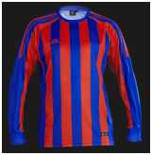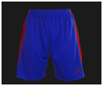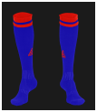

Please choose the size below by marking your preferred size with a cross. All sizes are in inches. Please print and return this form with your registration:

For further assistance please get your child to try on a football shirt at your local sports retailer to see which size fits best.

Child Name: ______________________ Team: ____________________

Top |  | Preference |  | Shorts |  | Preference
Small Boys | 26/28 |  |  | Small Boys | 21/23
Boys | 30/32 |  |  | Boys | 24/26
Youth | 34/36 |  |  | Youth | 27/29
Small Mens | 38/40 |  |  | Small Mens | 30/32
Socks |  | Preference
Shoe Size  (Small Boys) | 12 - 2
Shoe Size  (Large Boys) | 2 - 6
Shoe Size (Mens) | 7 -11

If your child is the designated goalkeeper for the team, complete the following:
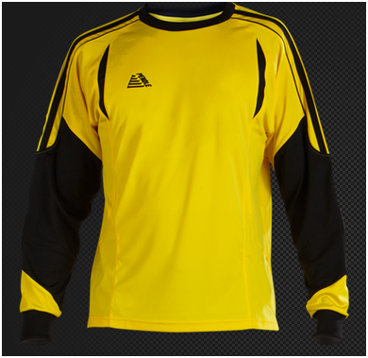
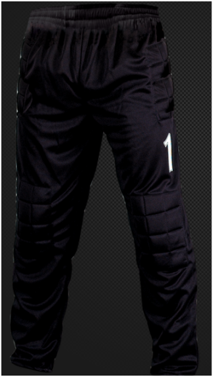
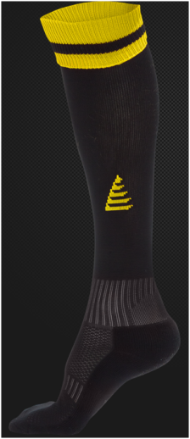

Please choose the size below by marking your preferred size with a cross. All sizes are in inches. Please print and return this form with your registration:

Goalkeeper Top |  | Preference |  | Goalkeeper Trouser |  | Preference
Small Boys | 26/28 |  |  | Small Boys | 21/23
Boys | 30/32 |  |  | Boys | 24/26
Youth | 34/36 |  |  | Youth | 27/29
Small Mens | 38/40 |  |  | Small Mens | 30/32
For further assistance please get your child to try on a football shirt at your local sports retailer to see which size fits best.

Child Name: ______________________ Team: ____________________

Socks |  | Preference
Shoe Size  (Small Boys) | 12 - 2
Shoe Size  (Large Boys) | 2 - 6
Shoe Size  (Mens) | 7 -11

FA Respect Code of Conduct for Spectators:

FA Respect Code of Conduct for players

FORM 4: Signing up to the FA Respect Codes of Conduct
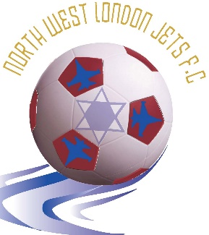
Chairman: Yoni Weichselbaum
Secretary: Aaron Weichselbaum

Respect Codes of Conduct Agreement

We have read and welcome the adoption by North West London Jets FC of the FA’s Respect Campaign.

We will do our utmost to ensure that the Code of Conduct is upheld at all times.

Player name: ___________________________

Player Signature: ___________________________

Parent name: ___________________________

Parent signature: ___________________________

Date: ___________________________

For office use:

Club secretary: ___________________________

FORM 5: North West London Jets (NWLJ) Consent Form

By signing this form I/we consent to my/our daughter’s/son’s:

- being filmed, photographed or otherwise recorded (“Performance”) by authorised photographers/videographers of NWLJ in connection with NWLJ football matches, training drills, team photographs or other team events/activities only;
- inclusion of their Performance in any recordings made by or on behalf of NWLJ, including (but not be limited to) any photographs, audio and audio visual recordings (“Footage”) in connection with NWLJ football matches, training drills, team photographs or other team events/activities only; and
- exploitation of their Performance as part of the Footage on the NWLJ website ([www. nwlj.co.uk ]), or in the Jewish News or Jewish Chronicle, all solely for the purposes of accompanying match reports or features on NWLJ.

In addition, I/we, on behalf of my/our daughter/son, hereby:

- assign (with full title guarantee) all Intellectual Property Rights in the Performance and Footage to NWLJ (including by way of present assignment of future copyright) for the full duration of such rights; and
- waive all Moral Rights in the Performance and the Footage. You hereby transfer and assign to NWLJ the making available right.

I/we acknowledge that NWLJ or authorised third parties may edit, adapt, alter, modify, translate and transcribe the Footage or Performance and exploit the edited, adapted, altered, modified Performance and/or Footage in whole or in part as set out above.

I/we understand that NWLJ will not publish details or give any third party details of my/our daughter’s/son’s name, address, school attended or other personal information under any circumstances. References in the Performance and Footage will only be that of the team name “North West London Jets”, age group and activity.

For the purposes of this Consent Form, “Intellectual Property Rights” shall mean all copyright, neighbouring rights, rights in performance, trade marks (registered or unregistered) and registered designs or unregistered design rights and any other intellectual property rights or other rights of a similar nature existing anywhere in the world, and “Moral Rights” shall mean any rights to claim authorship of a performance or any work, to object to or prevent the modification of a performance or any work and/or to withdraw from circulation or control the publication or distribution of a performance or any work and any similar rights existing under the law, practice or convention of any country in the world.

PARENTAL/GUARDIAN CONSENT

I, the Mother/Father/Guardian of _____________, have read and understood the terms and conditions set out above and have explained them to ___________.

I agree that the terms set out above are to the benefit of ___________ and are in his/her best interests. Any restrictions imposed by the terms above are fair and customary and are outweighed by the advantages immediately and potentially available to ___________.

I sign below on my own account and on my daughter’s/son’s behalf.

PRINT NAME________________________ SIGNATURE________________________

RELATIONSHIP_____________________ DATE OF SIGNATURE__________________

