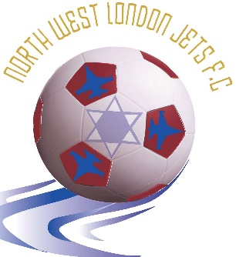
Chairman: Yoni Weichselbaum
Secretary: Aaron Weichselbaum

Dear Parents,

Thank you for expressing an interest in your daughter/son playing football with North West London Jets (NWLJ) in the 2020-21 season. NWLJ is an inclusive football club for Jewish children and young people. We offer after-school training by FA certified coaches. Our teams participate in the Excel Academy Youth Football League.

This pack contains all the information you need to register your child for participation in weekly after-school training and matches on Sundays.

In order to register your child to participate in the Excel Youth Academy Football League you need to provide the following:

- A copy of the player’s birth certificate or passport.
- A completed NWLJ registration form.
- A completed consent form giving NWLJ permission to take and use photos of your child on their website (optional)
- NWLJ kit order form (for new players or players who require a new kit).
- Respect Code of Conduct Agreement.

The cost for registering your child to play and train for the year is £360 and covers three terms of training at Mill Hill Power League, playing in matches in the Excel Youth Academy Football League, A North West London Jets Football kit, football equipment, insurance, the annual awards and payments to coaches and other expenses. This can be paid in instalments (see registration form for details).
The cost for training only is £70 per term or £210 for the year.

In accordance with the Data Protection Regulatory Policy (GDPR), North West London Jets have published policies and details available to view on the website here & here and is fully compliant with the stipulated requirements.
Please return the aforementioned forms to the address below. Cheques should be made payable to North West London Jets. Alternatively, you can pay by bank transfer: Branch sort code: 51-50-11, Account number: 66597056. If you have any questions, please contact Aaron on 07956 121740 or email aaronnwlj@hotmail.co.uk.

Contents
North West London Jets 3
About us 3
Training: 3
Times for training are as follows: 3
Sunday Matches: 4
Match format for each age group is as follows: 4
Team Organiser: 5
FORM 1: North West London Jets FC Registration Form 6
Football Kit Requirements 8
FORM 2: North West London Jets Kit 9
FA Respect Code of Conduct for Spectators: 11
FA Respect Code of Conduct for players 12
FORM 3: Signing up to the FA Respect Codes of Conduct 12
FORM 4: North West London Jets (NWLJ) Consent Form 14

North West London Jets

About us

North West London Jets is an inclusive Jewish football club for children and young people. We pride ourselves on providing a safe, enjoyable yet disciplined environment for our players to develop both as footballers and people. We believe all players should be treated equally and given the opportunity to be part of a great team.

We provide a great introduction to football, which ensures that all players:

- Take an active part in the game
- Learn to play as a team
- Understand the rules
- Develop football skills
- Are able to take part whatever their ability
- Develop fitness
- Enjoy themselves

We set a standard for behaviour on and off the pitch. Fair play and respect for other people is very important to our club and we strive to make sure that all children and parents alike show respect for other players, coaches, supporters and match officials.

Training:

- The coaching is carried out by FA qualified coaches.
- We develop coaching sessions to enable each child to fulfil their potential.
- Priority for playing on Sundays is given to children that train with NWLJ.
- Training takes place on Wednesday evenings at Mill Hill Power League, Pursley Road, Mill Hill.

Times for training are as follows:
Age Group | Time of Training
Under 7’s | 4:30pm – 5:30pm
- The cost of training on its own per term is £70.

Sunday Matches:

Age Group | Venue for Matches
Under 7’s | St Michael’s School, High Elms Lane, Garston, WD25 0SS
- NWLJ participates in the Excel Academy Football League for ages 6-7. Matches take place on Sunday afternoons at the following locations:
- Kick off times in the Excel Academy Football League are at 1:00pm
- These times are set by the Excel Academy Football League.

Match format for each age group is as follows:

Age Group | Match Format | Length of Match
Under 7’s | 5 v 5 | 40 minutes (4 quarters of 10 minutes)

- Players must arrive at the match venue 20 minutes before the stated kick-off time.
- Each week, you will be asked to confirm your child’s attendance. Those that confirm by the deadline will get priority for playing on Sunday.
- Children should bring a bottle of water or another still drink to games and training.
- When attending Excel Academy Football matches parents must stand behind the perimeter fencing at all times. Only the team organiser is allowed pitch-side.
- Your support during matches helps motivate the players and team. Come along and support the players.

Team Organiser:

Each team is organised by volunteers. The role of the team organiser is to:

- Decide team selection, composition, positioning of players and substitutions.
- Stand on the touch-line giving encouragement and guidance to players.
- Remain with players until parents/nominated guardians have collected them.
- Provide feedback to the coaches that train the players during the week.

Team organisers play an important but challenging role. If you are interested in becoming a team organiser or helping out on the touchline, please let us know.

FORM 1: North West London Jets FC Registration Form

North West London Jets – Registration Form

Name of Player:

Player’s Date of Birth (DOB):

Age Group registering for: Please tick the appropriate box.

Under 7

School Attended:

School Year starting September 2020: Please tick the appropriate box.

Year 1 | Year 2

Home Address:

Medical / Additional Educational Needs Information: Please provide information about any medical conditions / related medication and / or additional educational needs that could affect the player’s behaviour or performance.

Parent/ Carer Contact Details:

Name of Parent/ Carer:

Mobile Number 1: Name of Contact

Mobile Number 2: Name of Contact

Home Phone Number:

Parents/ Carer Email Addresses:

Name of Email Address owner:

Is your son/daughter Playing and Training? Training Only? Playing Only?
Please tick the appropriate box.
Playing & Training | Training Only | Playing Only

NB players are expected to attend training and dispensation will only be granted in circumstances where training sessions clash with school commitments.

Payment Enclosed for: Please tick the appropriate box.
£120 First Instalment (Playing & Training)
£240 First & Second Instalment (Playing & Training)
£360 for Whole Year Playing & Training (Instalment 1,2 and 3)
£70 for Term 1 (Training Only)
£140 for Term 1 & Term 2 (Training Only)
£210 for Whole Year Training Only (Instalment 1,2 and 3)
£70 First Instalment (Playing Only)
£140 First & Second Instalment (Playing Only)
£210 for Whole Year Playing Only (Instalment 1, 2 and 3)
£40 for 9 Monthly Instalments paid by standing order (Playing & Training)

Payment Method: Please tick the appropriate box.
Bank Transfer | Cheque

Instalment Payment Dates:

Activity | Instalment | Instalment Due Date
All | One | When the season starts
 | Two | 29th November 2020
 | Three | 28th February 2021
 | Monthly | 28th of each month  (September 2020 to May 2021

Please make cheques payable to North West London Jets.
If you are paying by Bank Transfer please use the following: Branch sort code: 51-50-11, Account number: 66597056.

FORM 2: Maccabi MJFL League Registration Form

Football Kit Requirements

NWLJ has a kit comprising shirt, shorts and socks. The kit comes in a range of sizes and you can order a kit using the form in this pack. The cost for full kit is £35 and is only applicable to new players who do not currently own one or existing players who require a new kit.

Children will also need to bring:

- Shin pads
- Appropriate shoes: Trainers or astro-turf boots (preferred as they reduce slipping).

Players will be unable to participate in Sunday matches and training without shin pads and the correct footwear.

FORM 2: North West London Jets Kit

The purchasing and wearing of the NWLJ kit are mandatory for playing on Sundays. The NWLJ kit is specifically designed for us and includes the club insignia on the shirt.
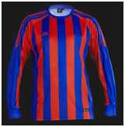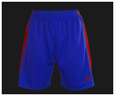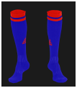

Please choose the size below by marking your preferred size with a cross. All sizes are in inches. Please print and return this form with your registration:

For further assistance please get your child to try on a football shirt at your local sports retailer to see which size fits best.

Child Name: ______________________ Team: ____________________

Top |  | Preference |  | Shorts |  | Preference
Small Boys | 26/28 |  |  | Small Boys | 21/23
Boys | 30/32 |  |  | Boys | 24/26
Youth | 34/36 |  |  | Youth | 27/29
Small Mens | 38/40 |  |  | Small Mens | 30/32
Socks |  | Preference
Shoe Size  (Small Boys) | 12 - 2
Shoe Size  (Large Boys) | 2 - 6
Shoe Size (Mens) | 7 -11

If your child is the designated goalkeeper for the team, complete the following:
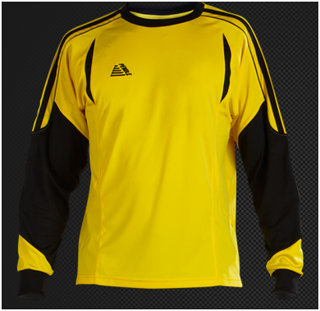
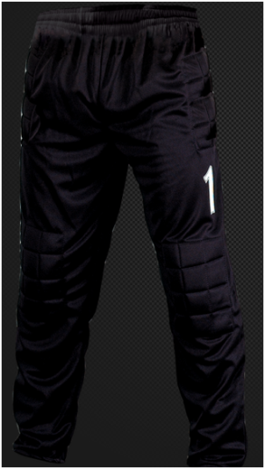
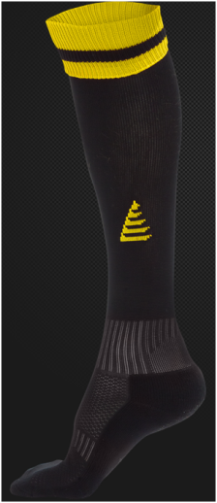

Please choose the size below by marking your preferred size with a cross. All sizes are in inches. Please print and return this form with your registration:

Goalkeeper Top |  | Preference |  | Goalkeeper Trouser |  | Preference
Small Boys | 26/28 |  |  | Small Boys | 21/23
Boys | 30/32 |  |  | Boys | 24/26
Youth | 34/36 |  |  | Youth | 27/29
Small Mens | 38/40 |  |  | Small Mens | 30/32
For further assistance please get your child to try on a football shirt at your local sports retailer to see which size fits best.

Child Name: ______________________ Team: ____________________

Socks |  | Preference
Shoe Size  (Small Boys) | 12 - 2
Shoe Size  (Large Boys) | 2 - 6
Shoe Size  (Mens) | 7 -11

FA Respect Code of Conduct for Spectators:

FA Respect Code of Conduct for players

FORM 3: Signing up to the FA Respect Codes of Conduct
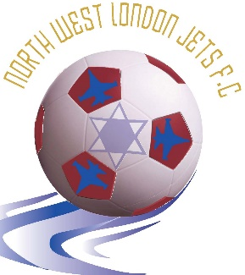
Chairman: Yoni Weichselbaum
Secretary: Aaron Weichselbaum

Respect Codes of Conduct Agreement

We have read and welcome the adoption by North West London Jets FC of the FA’s Respect Campaign.

We will do our utmost to ensure that the Code of Conduct is upheld at all times.

Player name: ___________________________

Player Signature: ___________________________

Parent name: ___________________________

Parent signature: ___________________________

Date: ___________________________

For office use:

Club secretary: ___________________________

FORM 4: North West London Jets (NWLJ) Consent Form

By signing this form I/we consent to my/our daughter’s/son’s:

- being filmed, photographed or otherwise recorded (“Performance”) by authorised photographers/videographers of NWLJ in connection with NWLJ football matches, training drills, team photographs or other team events/activities only;
- inclusion of their Performance in any recordings made by or on behalf of NWLJ, including (but not be limited to) any photographs, audio and audio visual recordings (“Footage”) in connection with NWLJ football matches, training drills, team photographs or other team events/activities only; and
- exploitation of their Performance as part of the Footage on the NWLJ website ([www. nwlj.co.uk ]), or in the Jewish News or Jewish Chronicle, all solely for the purposes of accompanying match reports or features on NWLJ.

In addition, I/we, on behalf of my/our daughter/son, hereby:

- assign (with full title guarantee) all Intellectual Property Rights in the Performance and Footage to NWLJ (including by way of present assignment of future copyright) for the full duration of such rights; and
- waive all Moral Rights in the Performance and the Footage. You hereby transfer and assign to NWLJ the making available right.

I/we acknowledge that NWLJ or authorised third parties may edit, adapt, alter, modify, translate and transcribe the Footage or Performance and exploit the edited, adapted, altered, modified Performance and/or Footage in whole or in part as set out above.

I/we understand that NWLJ will not publish details or give any third party details of my/our daughter’s/son’s name, address, school attended or other personal information under any circumstances. References in the Performance and Footage will only be that of the team name “North West London Jets”, age group and activity.

For the purposes of this Consent Form, “Intellectual Property Rights” shall mean all copyright, neighbouring rights, rights in performance, trade marks (registered or unregistered) and registered designs or unregistered design rights and any other intellectual property rights or other rights of a similar nature existing anywhere in the world, and “Moral Rights” shall mean any rights to claim authorship of a performance or any work, to object to or prevent the modification of a performance or any work and/or to withdraw from circulation or control the publication or distribution of a performance or any work and any similar rights existing under the law, practice or convention of any country in the world.

PARENTAL/GUARDIAN CONSENT

I, the Mother/Father/Guardian of _____________, have read and understood the terms and conditions set out above and have explained them to ___________.

I agree that the terms set out above are to the benefit of ___________ and are in his/her best interests. Any restrictions imposed by the terms above are fair and customary and are outweighed by the advantages immediately and potentially available to ___________.

I sign below on my own account and on my daughter’s/son’s behalf.

PRINT NAME________________________ SIGNATURE________________________

RELATIONSHIP_____________________ DATE OF SIGNATURE__________________

